The University of Azad Jammu and Kashmir, Muzaffarabad
Name | Danial Ayub Mughal
Roll Number | 2024-SE-20
Class | 4rd Semester
Subject | Computer Networks (Lab task 03)
Course Code | CS-2203
Submitted To | Engr. Dr .Asma Javaid


Department of Software Engineering

Ethernet Cable Making & Testing
An Ethernet cable is a type of wired network cable used to connect devices like computers, routers, and switches to a local network (LAN) or the internet.
It transfers data between devices—basically giving you a stable and fast internet connection compared to Wi-Fi.

Objective
The objective of this lab task was to:
- Learn how to construct an Ethernet cable using proper wiring standards
- Understand the use of RJ-45 connectors
- Test the cable using a network cable tester
- Verify whether the cable is properly working or not

Materials Required
- Ethernet Cable (UTP Cable)
- RJ-45 Connectors
- Crimping Tool
- Cable Cutter/Stripper
- Cable Tester (RJ-45/RJ-11/USB/BNC tester)
Procedure
- Cable Preparation
First, the outer insulation of the Ethernet cable was carefully removed using a cable stripper. Inside, 8 colored wires were exposed.
- Wire Arrangement (Standard)
The wires were arranged according to the T568B wiring standard, which is commonly used.
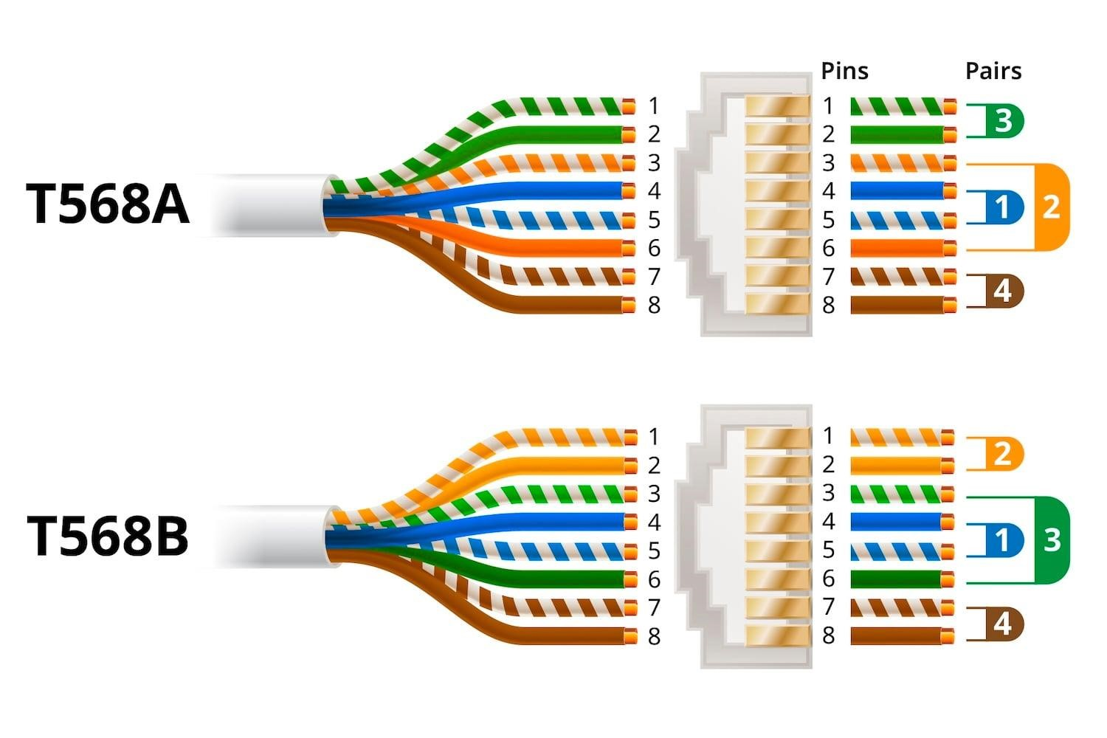
T568B Color Order:
  - White-Orange
  - Orange
  - White-Green
  - Blue
  - White-Blue
  - Green
  - White-Brown
  - Brown
- Inserting into RJ-45 Connector
  - The arranged wires were straightened and cut evenly
  - Inserted into the RJ-45 connector carefully
  - Ensured all wires reached the end properly
- Crimping
  - The connector was inserted into the crimping tool
  - Pressed tightly to fix the wires inside the connector
- Repeating for Other End
The same process was repeated on the second side of the cable.
- Cable Testing
The cable was tested using a cable tester (as shown in the image).
Observation From Tester:
The LED lights from 1 to 8 turned on sequentially The CONNECTED light was ON (blue light) No indication of:
o Short circuit ❌ o Non-parallel wiring no connection

Result
The Ethernet cable was successfully constructed and tested.
All pins were properly connected, and the cable is fully functional and working correctly.

Conclusion
This lab activity helped in understanding the practical process of making an Ethernet cable. It also improved knowledge about wiring standards and the use of cable testers. The successful testing confirmed that the cable was properly assembled without any faults.

Precautions
- Ensure correct wire color order
- Cut wires evenly before inserting
- Push wires fully into connector
- Crimp properly to avoid loose connections
- Always test cable after making
